Home work 02-10-2023

**1.Print Hello World**

**Addition of two numbers**

**Multiplication of two numbers.**

**Division of two numbers**

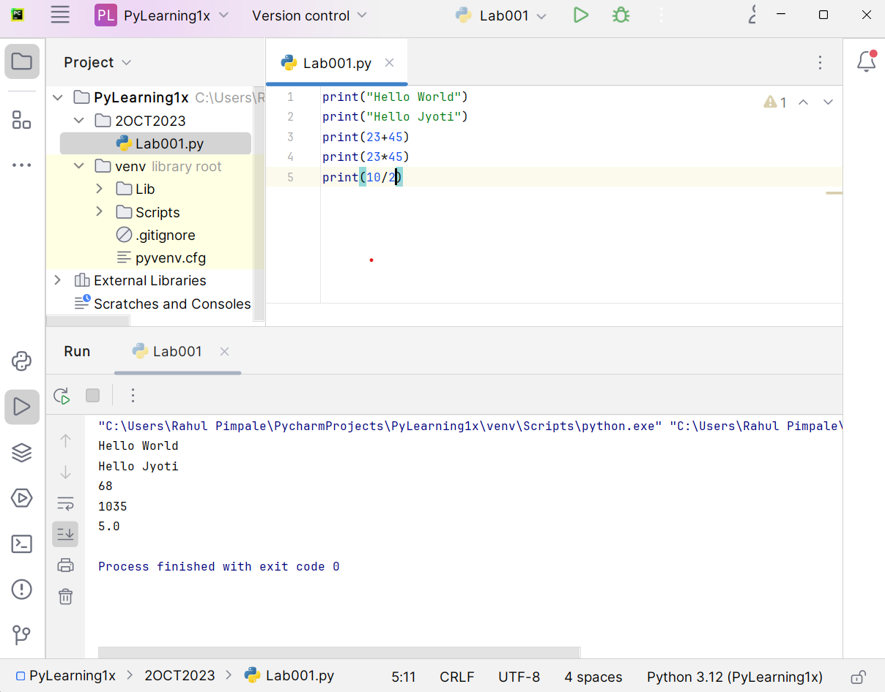

2**.Compiler & Interpretation difference**

A Compiler takes a program as a whole.

The Compilers generate intermediate machine codes

Examples of compiled programming languages are C and C++.

An Interpreter takes single lines of a code.

The Interpreters never generate any intermediate machine codes.

Interpreter directly executes instructions written in a programming or scripting language without previously converting them to an object code or machine code.

Examples of interpreted languages are Perl, Python and MATLAB .